From: https://goldswitzerland.com/liftoff-collapse/

**LIFTOFF & COLLAPSE**

October 28, 2020

by Egon von Greyerz



Get ready for the biggest collapse in the history of mankind. It will be devastating and reach all parts of society, economic, financial, political & social.

But wait, it won’t happen just yet. Because before that the world will experience a LIFTOFF in markets of gigantic proportions. This will be the grand finale of this financial era. It will involve inflationary liquidity injections of proportions never seen before in history and lead to a massive explosion in many asset markets.

Most investment assets will benefit as the disconnect between markets and reality grows to distortionary proportions.

TRUMP – YOU WIN! BIDEN – YOU WIN!

So there we have it. For investors the outcome of this election is totally irrelevant. In four years time, the difference for the economy and markets between a Trump or Biden victory will be insignificant.

Either one of them only has one choice. They are both facing a bankrupt country which has been running budget deficits since 1930 with four years of exception in the 1940s-50s. The Clinton surpluses were fake. Also, the US has had trade deficits for almost 50 years. The consequence has been an exponentially surging debt which was under $1 trillion when Reagan became President in 1981 and is now $27t. In the next four years, a $40t debt is guaranteed [as I forecast four years ago](https://goldswitzerland.com/the-2007-9-crisis-will-return-in-2018-with-a-vengeance/) but as the financial system implodes, the debt could easily run into $100s of trillions or $ quadrillions when the derivative bubble bursts.

The global financial system should have collapsed already in 2006-9 but the central banks managed to delay the inevitable demise for over a decade.

SUPER CYCLE BULL MARKETS END IN EUPHORIA

What we must understand is that the end of an economic supercycle doesn’t happen quietly. No, the conditions need to be uber-euphoric with maximum bullishness for the economy and stocks. This means that before this era is over, markets must surge in the final months, even double over a 9-18 months period.

Multiple factors are now in place for this to happen. Firstly both presidential candidates will need not just fistfuls of dollars but quantum computers that can print the required trillions and quadrillions of dollars.

The convenient excuse they have is of course Covid. Individuals not working need money, companies need money, municipalities, states and the Federal government need money.

But we mustn’t forget how the end of the final phase of this economic era started. This was back in Aug-Sep 2019 when the Fed and the ECB shouted out from the roof tops that were going to **do what[ever] it takes** to save the system. They didn’t tell us what the problems were, but it was clear to some of us who understood the fragility of the financial system that it was in dire straits. When the last crisis started in 2006, the Fed’s balance sheet was $830b. At the end of the Great Financial Crisis in 2009, the balance sheet had grown to $2t.

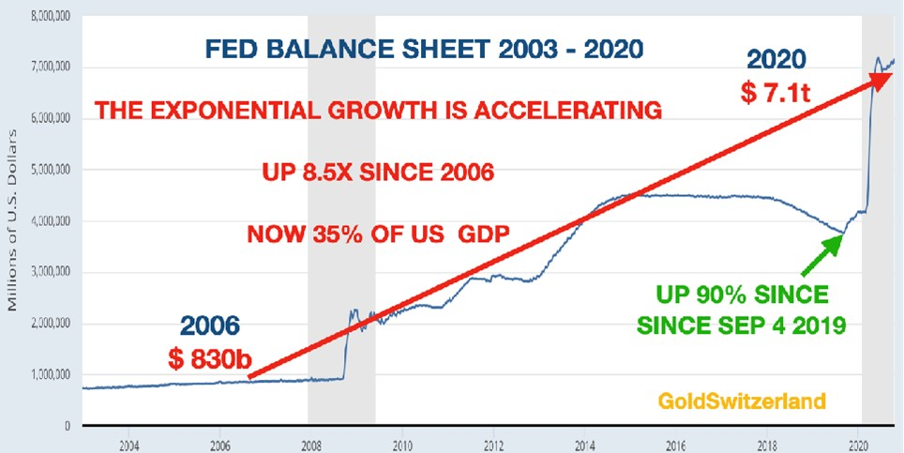

But no one must believe that the problem had been solved by 2009. All it was, was a temporary stay of execution. Why otherwise would the Fed’s balance sheet have grown by another $5t since 2009. Just looking at the predicted budget deficits in the next 4 years, plus accelerating problems in the financial system the Fed’s balance sheet is likely to explode in coming years.

LIQUIDITY INJECTIONS WILL GIVE SHORT TERM BENEFIT TO THE ECONOMY

So the conditions are in place for the biggest liquidity injection in financial history. For many years we have experienced a total disconnect between economic reality and markets. The coming acceleration in money printing and liquidity injections in to the financial system will be so overwhelming that it will not just fuel markets but also give a short term, albeit artificial, boost to the economy.

This is a typical course of events at the beginning of an inflationary phase which leads to hyperinflation as the currency collapses.

The paralysation of the world economy due to Covid will probably peak with the current second wave and therefore add to the optimism in markets. But no one must believe that the pandemic is the cause of the problems in the world economy. No, it has just been a very vicious catalyst which hit an already fragile financial system.

When Covid gradually slows down, the initial optimism combined with the flooding of the system with printed money might last for a year or so. But as the world realizes that you cannot solve a debt problem with more debt, the real difficulties in the economy and the financial system will reemerge with a vengeance.

FROM BOOM TO BUST

So let us look at a possible scenario of events following the election:

**New president will flood the economy with money & boost stocks**

Initial market volatility will settle down quickly and investors will respond optimistically to the new president’s promises of support to every corner of the economy.

Stock markets will surge and could double over a 9-18 month period. No cash will be left on the sidelines. Both institutions and retail investors will throw all the cash they have at the stock market. There will be a frenzy which will surpass the tech stock boom in the 1990s. There will be fanfares and blazing guns as the market seems unstoppable.

But after the likely short-term boom, there will be tears as markets fall by over 90% in real terms. And sadly most investors will ride the stock market all the way down. The big difference this time is that central banks will not and cannot save them.

**COMMODITIES WILL BOOM**

The biggest beneficiary of this coming boom will be **commodity markets** which are at a 50 year low versus stocks. Looking at the chart below, the minimum target would be commodities outperforming stocks by 4 to 1. Eventually a new high in commodities against stocks is likely. This would mean commodities outperforming stocks by 20x. The first part of this outperformance will come as stock markets rise. But the final phase will be when general stock markets collapse and commodities continue to strengthen. Goldman Sachs expect commodities to rise 28% in 2021. They expect inflation plus a commodities deficit will drive prices higher. And this is of course what the chart below tells us.

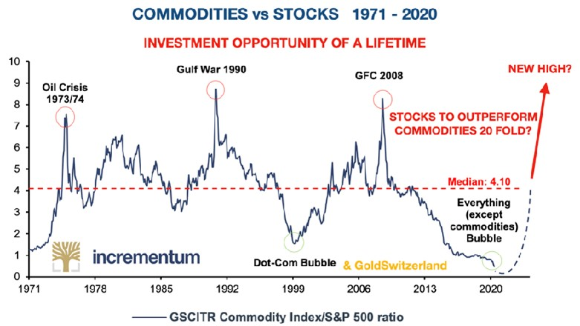

PRECIOUS METALS WILL SHINE

Gold, silver and platinum will vastly outperform stocks. The Dow – Gold ratio will initially reach 1 to 1 where it was in 1980 when gold was $850 and the Dow index 850. Eventually the ratio will reach at least 0.5 to 1 which means that the Dow will lose 97% against gold in the next five years.

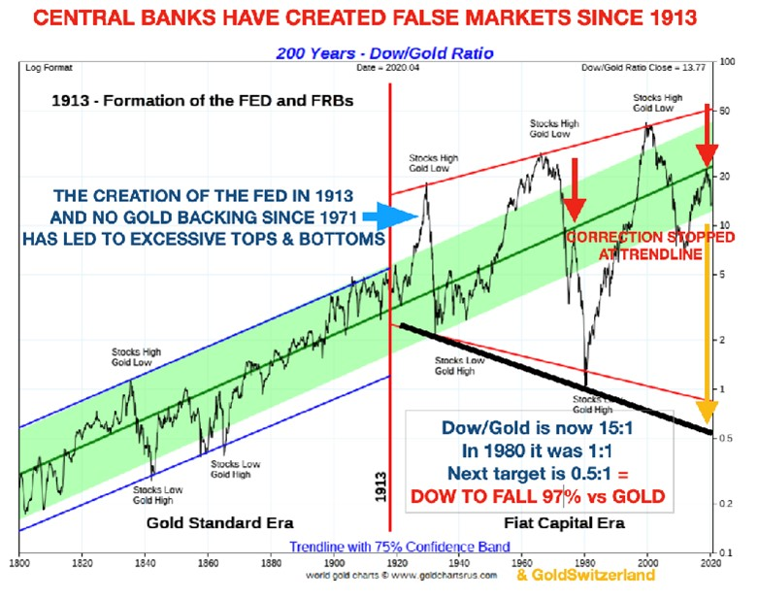

Goldman Sachs expects gold to reach $2,300 in 2021 but I believe that target is too conservative. Before gold breaks out above the August high at $2,074, a correction down to $1,800-20 is possible and would not change gold’s unstoppable rise. In this latest phase, gold is in a bull market or more correctly, the currencies are in a bear market since 1999. The continued debasement of the currencies is guaranteed by the central banks since they only have one option – **TO PRINT AND PRINT AND PRINT until money dies.**

We must remember that gold is the king of the metals and therefore the safest precious metal to hold. But initially at least, silver and platinum will strongly outperform gold but with massive volatility.

Vital to hold physical metals stored in safe vaults in the investor’s name, outside the banking system. It is important not to forget that the risks in the financial system will be at a maximum for the next few years and a failure can happen at any time.

PRECIOUS METALS MINING STOCKS

For the smart investor, this is where more money will be made than in any area of stocks or other investments. Especially the juniors will really shine. But this is a market for specialists. So either best to follow some of the smartest investors in this area or to buy an index of these stocks. There will be many 10-20 baggers and even some 100 baggers but obviously also some losers. So important to have a spread.

The biggest risk with mining stocks is that they are normally held within the financial system. So even though they are a terrific investment opportunity, they are not the best form of wealth preservation. Therefore it is safer to have a much bigger allocation to the physical metals which, even though they will underperform the mining stocks, will see massive capital appreciation.

The chart below shows XAU gold – silver index against the Dow since 1983 when the XAU was introduced. Since then the XAU has lost 95% against the Dow. This fall is likely to be reversed in the next few years with the XAU going up 20x against the Dow . For Dow investors this means losing 95% against mining stocks.

And sadly, this is what will happen to 99% of investors as they stick to their ordinary stocks and miss the most incredible opportunity.

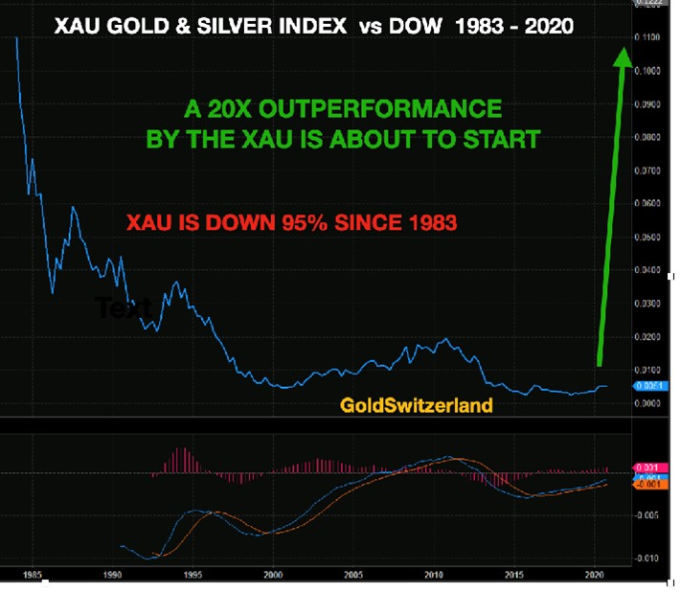

DOLLAR

Printing unlimited amounts of money always has consequences. Since 1971 the dollar has lost 98% in real terms which means against gold since gold is the only money that has survived in history.

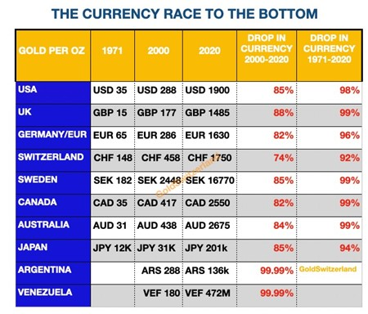

The dollar is now starting its final journey to ZERO and as the table shows, even a weak and artificial currency like the euro will outperform the doomed dollar.

A falling dollar will accelerate US inflation until it leads to hyperinflation.

INTEREST RATES

Interest market is probably the most contrarian of all trades today. The whole investment world, including the Fed and the ECB believe that rates will stay at zero or below for years to come. Normally when consensus is that strong, the opposite is more likely to happen.

Also, rising a weaker dollar will cause higher inflation which will put upward pressure on rates. As investors start selling the long end of the bond market, short rates will eventually follow.

Precious metals normally benefit from negative real rates which means that inflation is higher than interest rates. Gold can still rise strongly with high nominal rates as long as inflation is higher. We saw this happen in the 1970s to the early 1980s when rates reached 20% and gold went from $35 to $850. During that time, inflation remained higher than rates.

I remember this period well as I experienced it in the UK with my first mortgage reaching 21%.

FROM BOOM TO BUST

So there is now an opportunity for all investors to double their money in the stock market in the next 9-18 months as ever more liquidity will fuel stock markets.

But a Caveat Emptor (Buyer Beware) warning is in place here. Asset markets are already in a major bubble and the financial system is so fragile that it could break at any time.

So rather than chasing the last leg of this bull market which most investors will do, it will be much better to look at safer alternatives.

I have outlined them above. **Physical precious metals and precious metals stocks will outperform all other markets. And these all present the best risk.** Both the metals and the metal stocks will boom in the final phase of the stock market boom. And as stock markets top and then crash, the precious metals sector will continue to perform extremely well as currencies are debased.

As I stated above, the general stock market is likely to lose at least 95% against the precious metals sector in the next five years.

There has probably never before been such a clear choice in investment markets but sadly most investors will miss it. They will instead stick to their conventional portfolio which will include a lot of the already overvalued tech stocks.

Holding gold and silver stocks will be the investment opportunity of a life time. But since they are held within a vulnerable financial system, we believe that these holdings should represent a much smaller percentage than physical metals.

**To hold physical gold, silver and platinum outside the fragile banking system is the ultimate form of wealth preservation and insurance against a debt infested and unsafe financial system.**

With a portfolio of some precious metals stocks and physical metals, investors will be able to ride out the coming storm and volatility in markets and also benefit financially. Of course there will be volatility also in the metals market but the trend in the next 5+ years is virtually guaranteed.

So better to avoid the coming boom and bust in the general stock markets and stick to metals.

**[Egon von Greyerz](https://goldswitzerland.com/?p=12286)**  
Founder and Managing Partner  
Matterhorn Asset Management  
Zurich, Switzerland  
Phone: +41 44 213 62 45  
  
Matterhorn Asset Management’s global client base strategically stores an important part of their wealth in Switzerland in physical gold and silver outside the banking system. Matterhorn Asset Management is pleased to deliver a unique and exceptional service to our highly esteemed wealth preservation clientele in over 70 countries.  
[GoldSwitzerland.com](https://goldswitzerland.com/)  
[Contact Us](https://goldswitzerland.com/contact-us-become-a-client/)